SIT123: Data Capture Technologies

# Sensing Motion Activity Sheet

## Hardware Required

* Arduino Board
* USB cable

## HCSR505 PIR Passive Infra Red Motion Detector (<https://tronixlabs.com.au/sensors/motion/hcsr505-pir-passive-infra-red-motion-detector-australia/> )

* Male to Female Dupont Jumper Wires

## Pre-requisites: You must do the following before this task

**Read this sheet from top to bottom**

## Steps

1. Examine the motion sensor closely. Can you see a + sign at the base? This is the VCC pin, or the pin that should be connected to Arduino’s power pin. The middle pin on the sensor is the one that transfers sensor data. The last pin, with a - sign at the base is the Ground pin.

Connect your HCSR505 PIR Passive Infra Red Motion Detector to the Arduino board using the images & steps a, b and c included below for guidance.

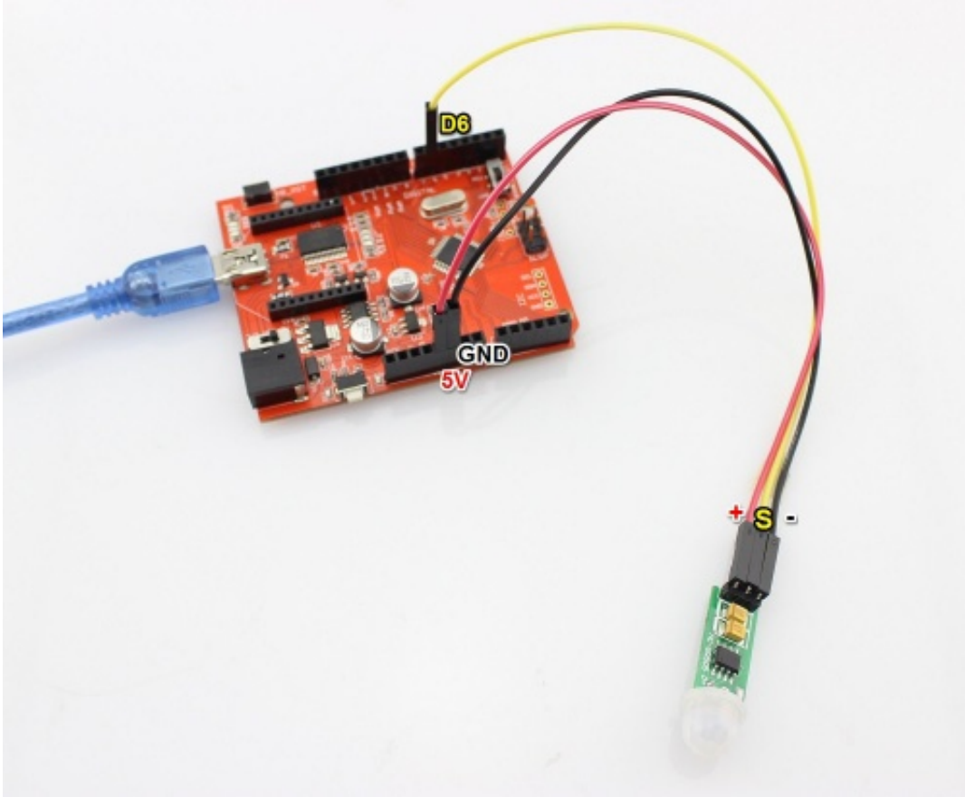

* 1. Pick a red male-female jumper wire and attach the female end to pin 1 (VCC pin) on the sensor. Plug the male end into the Arduino board’s 5V power pin.
  2. Pick a blue male-female jumper wire and attach the female end to pin 2 (DATA pin) on the sensor. Plug the male end into the Arduino board’s digital data pin 6.
  3. Pick a black male-female jumper wire and attach the female end to pin 4 (GND) on the sensor. Plug the male end into the Arduino board’s GND pin.

(These Red, Blue, Black colours don’t really matter. But it’s good to follow a standard for ease of use)

1. Connect your Arduino board to your computer using the USB cable.
2. Open your Arduino IDE
3. Download the provided code at https://github.com/FeifeiDeakin/HCSR505motion. If you download it in .zip format, you must extract it to a location on your computer after you download it.

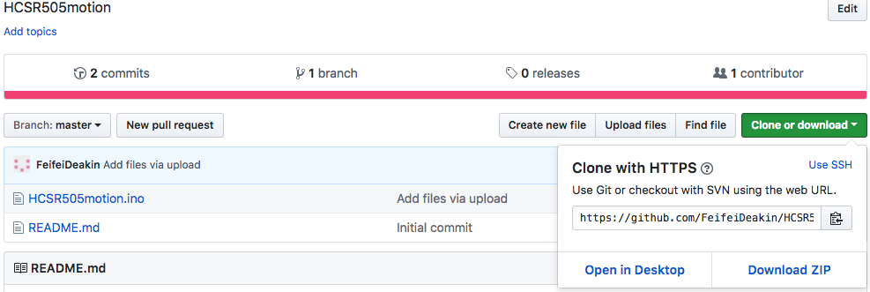

See: <https://support.microsoft.com/en-us/help/14200/windows-compress-uncompress-zip-files> for extracting zip files on Windows &

<https://support.apple.com/kb/PH25411?locale=en_US> for extracting zip files on Macs.

1. Go to the Arduino IDE. Select “File -> Open” and it will open a dialog box.

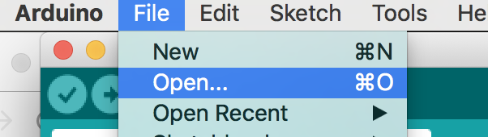

1. Select the HCSR505motion.ino file inside the HCSR505motion folder & click Open.
2. In your Arduino IDE, click on the ‘Verify’ button. This will check for errors and compile your code.
3. Use the “tools” menu to check the port to which the Arduino board is connected. Once the right port is selected, it is possible to upload sketches to Arduino.
4. Now click the upload icon to upload the code to the Arduino board. If you get an error, check to be sure you’ve selected the correct device and port.
5. Open the Serial Monitor in the Arduino IDE by selecting Tools->Serial Monitor, or by clicking on the Serial Monitor icon.

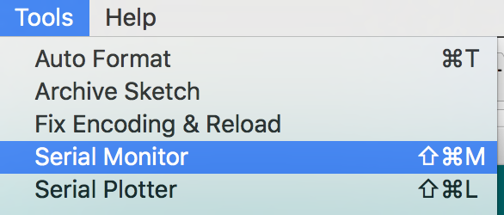

1. Wave your hand in front of the motion sensor. Observe what’s printed on the Serial Monitor!

Screen Shot 2017-06-01 at 2.21.18 pm.png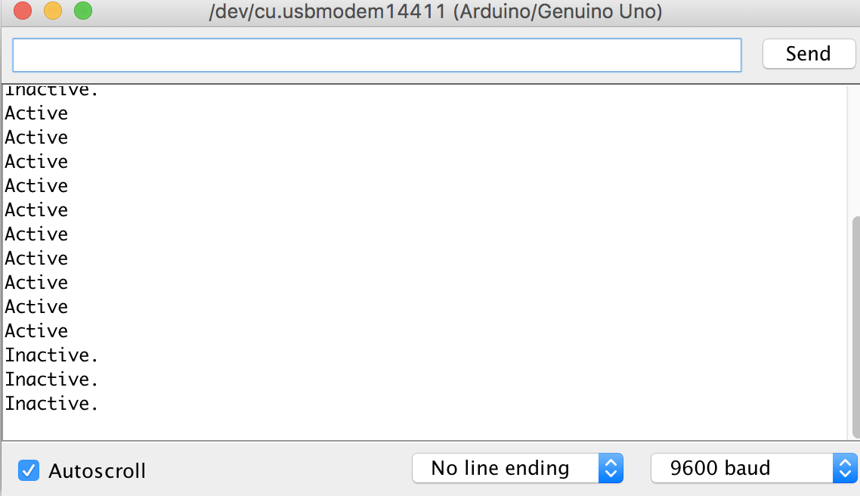

1. To get the data and save it, simply click on the Serial Monitor, Select all-> Then copy by CMD+C on Mac or Ctrl+C on Windows. Then paste to a text editor such as Notepad/Atom/Sublime Text and save it.

## References

<https://www.elecrow.com/wiki/index.php?title=HC-SR505_Mini_PIR_Motion_Sensor>

<https://docs.bsfrance.fr/documentation/10583_HC_SR505/HC-SR505.pdf>

<http://www.instructables.com/id/PIR-Motion-Sensor-Tutorial/>

<https://cdn-learn.adafruit.com/downloads/pdf/pir-passive-infrared-proximity-motion-sensor.pdf>